**GRoup - 07**

**Subhajit Chowdhury**

**Tarun Kamal Khiani**

**Liya Peter**

**Debasish Nayak**

Finance & Risk Analytics

Assignment – Credit risk

Contents

Goal 2

Classification using logistics regression 3

Data Cleansing & Determining default 3

Identifying Variables across categories to define default 3

Credit Default Equation 4

Credit Default Classification accuracy 4

# Goal

The goal of this assignment is to define a model that would define credit default.

# Classification using logistics regression

## Data Cleansing & Determining default

* ‘Networth Next Year’ was considered to determine default. If ‘Networth Next Year’ is negative then the company would default otherwise not.
* All null values were replaced with 0
* All variables were capped and floored to 95% 5%

## Identifying Variables across categories to define default

We ran the logistic regression for each variable and picked the one which is statistically significant and has the largest coefficient across each category.

|  |  |  |  |
| --- | --- | --- | --- |
| Profitability Variables | Company Size Variables | Liquidity Variables | Leverage Variables |
| PBDITA | Total assets | **Quick ratio (times)** | Debt to equity ratio (times) |
| Profit after tax | Net worth | Current ratio (times) | TOL/TNW |
| PBT | Sales | Cash to current liabilities (times) | **Total term liabilities / tangible net worth** |
| Cash profit | Total capital | Creditors turnover | Contingent liabilities / Net worth (%) |
| PBDITA as % of total income | **Reserves and funds** | Debtors turnover | Borrowings |
| PBT as % of total income | Shareholders funds | Finished goods turnover | Current liabilities & provisions |
| PAT as % of total income | Capital employed | WIP turnover | Total liabilities |
| Cumulative retained profits | Net fixed assets | Raw material turnover | Contingent liabilities |

**Variables finally chosen to be used in the credit Equation**

* `PBDITA as % of total income`
* `Reserves and funds`
* `Quick ratio (times)`
* `Total term liabilities / tangible net worth`

## Credit Default Equation

-1.9429490 - 0.0997095 * `PBDITA as % of total income` - 0.0023890 * `Reserves and funds` - 0.8465098 * `Quick ratio (times)` + 0.6847675 * `Total term liabilities / tangible net worth`

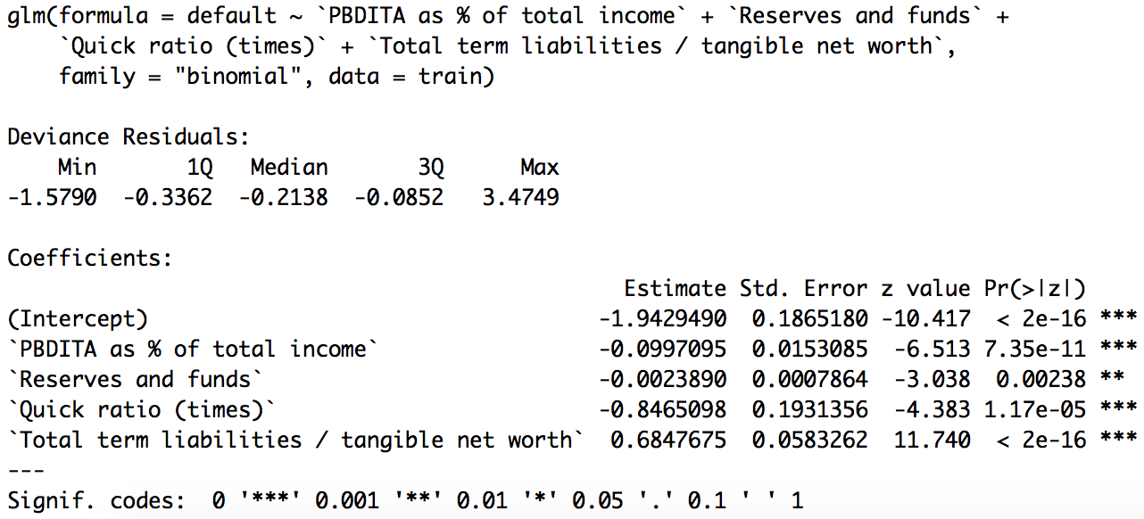

## Credit Default Classification accuracy

The model is robust as it provides similar results for test, train and the validation sample.

|  |  |  |  |  |  |  |
| --- | --- | --- | --- | --- | --- | --- |
|  | Training Sample | | Test Sample | | Validation Sample | |
| **Default Rate** | 6.62% | | 6.59% | | 7.55% | |
|  | Default Rate | % of default from all defaulters | Default Rate | % of default from all defaulters | Default Rate | % of default from all defaulters |
| **10 Decile** | 36.84% | 55.49% | 49.30% | 50.00% | 49.30% | 64.81% |
| **09 Decile** | 12.10% | 18.29% | 11.11% | 11.43% | 11.11% | 14.81% |
| **08 Decile** | 5.24% | 7.93% | 1.41% | 1.43% | 1.41% | 1.85% |
| **07 Decile** | 2.82% | 4.27% | 5.56% | 5.71% | 5.56% | 7.41% |
| **06 Decile** | 1.21% | 1.83% | 1.41% | 1.43% | 1.41% | 1.85% |
| **05 Decile** | 2.02% | 3.05% | 1.39% | 1.43% | 1.39% | 1.85% |
| **04 Decile** | 2.02% | 3.05% | 1.41% | 1.43% | 1.41% | 1.85% |
| **03 Decile** | 2.02% | 3.05% | 4.17% | 4.29% | 4.17% | 5.56% |
| **02 Decile** | 2.02% | 3.05% | 0.00% | 0.00% | 0.00% | 0.00% |
| **01 Decile** | 0.00% | 0.00% | 0.00% | 0.00% | 0.00% | 0.00% |